**WORKBOOK**

**UNIT 3**

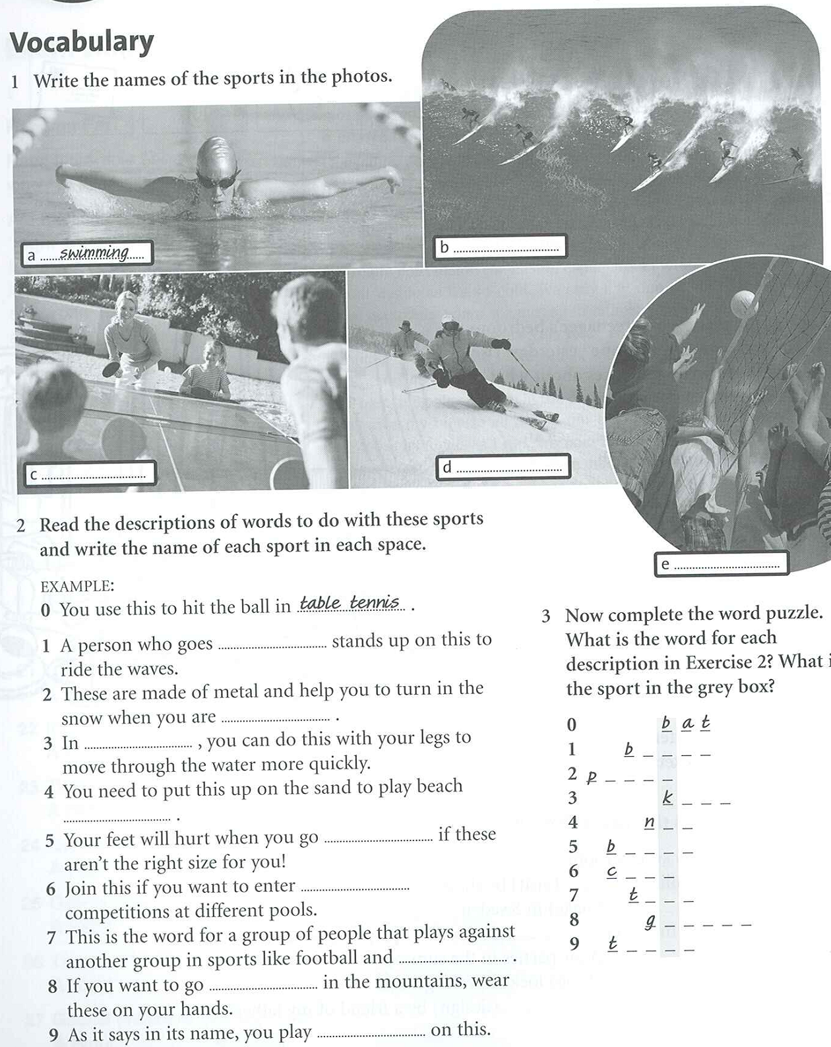

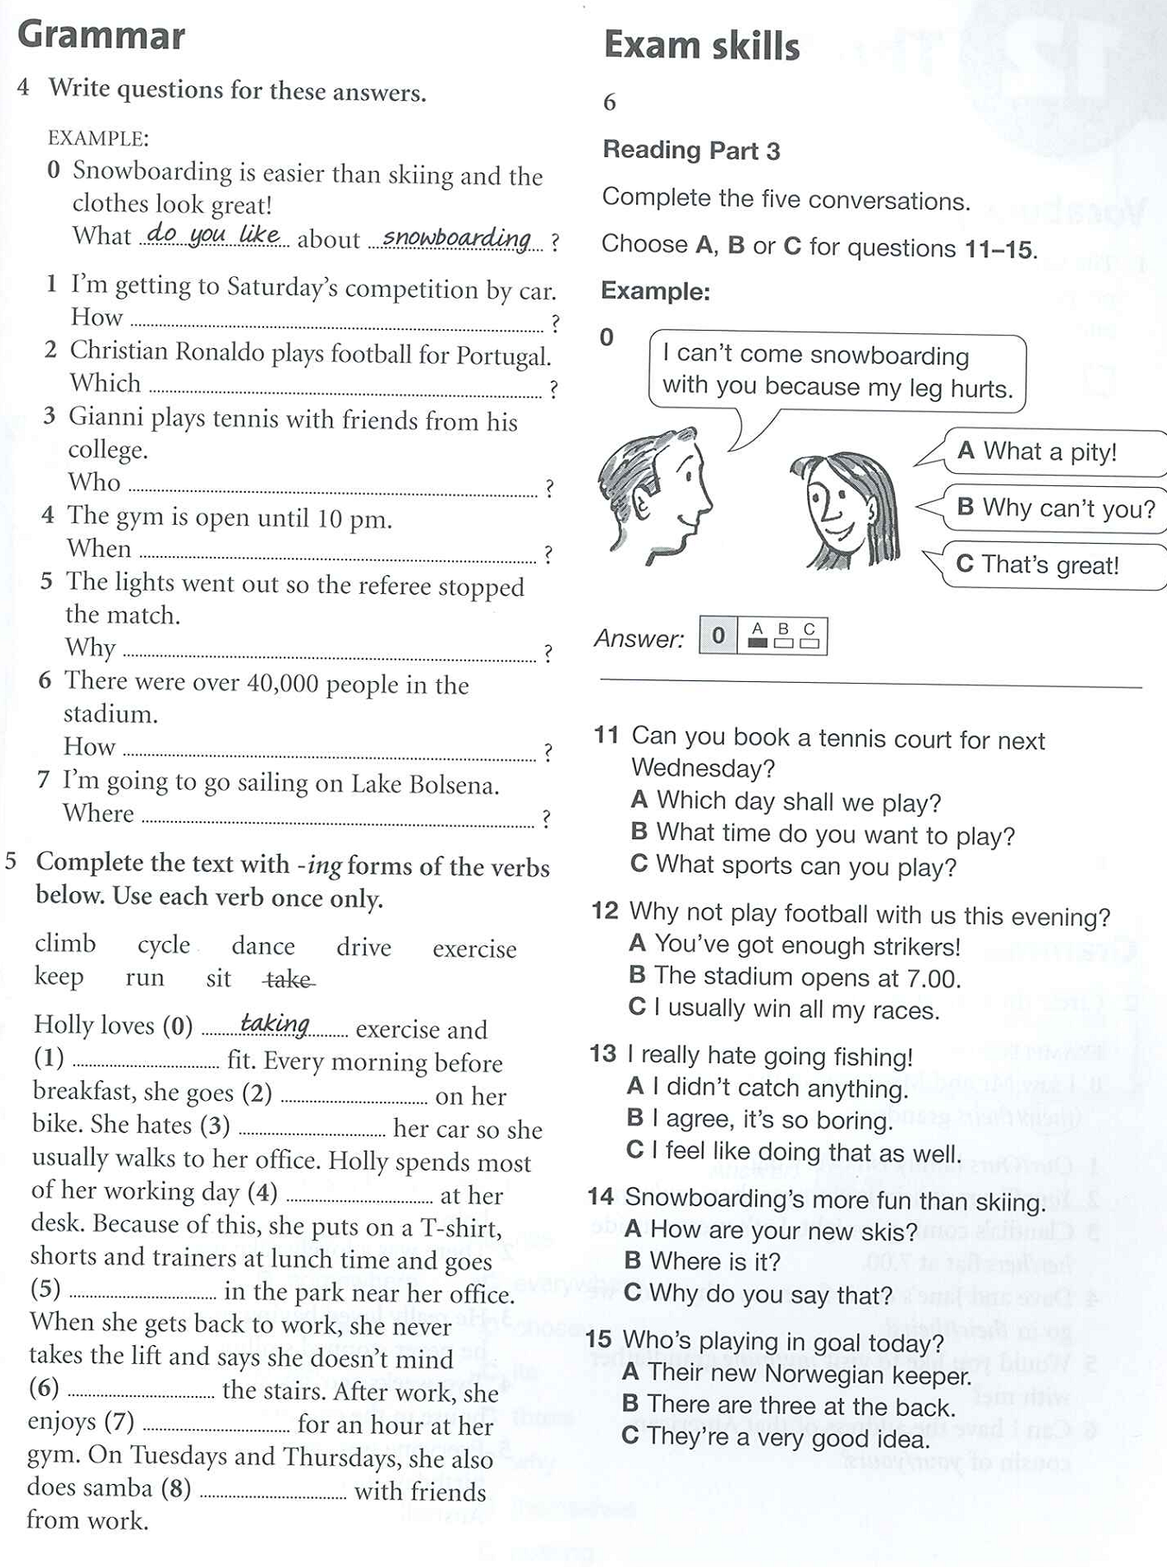

**ANSWER KEYS**

|  |  |
| --- | --- |
|  |  |

**Source**

Capel, A., & Sharp, W. (2011), *Objective KET Workbook.* Cambridge University Press.